TEST-2

A.GOWTHAMI

192111555

1. PROGRAM TO PRINT PATTERN:

#include <iostream>

using namespace std;

int main() {

int size;

cout << "Enter the size of the array: ";

cin >> size;

int arr[100];

cout << "Enter elements of the array:" << endl;

for (int i = 0; i < size; i++) {

cin >> arr[i];

}

int sum = 0;

for (int i = 0; i < size; i++) {

sum += arr[i];

}

cout << "Sum of all elements in the array: " << sum << endl;

return 0;

}  
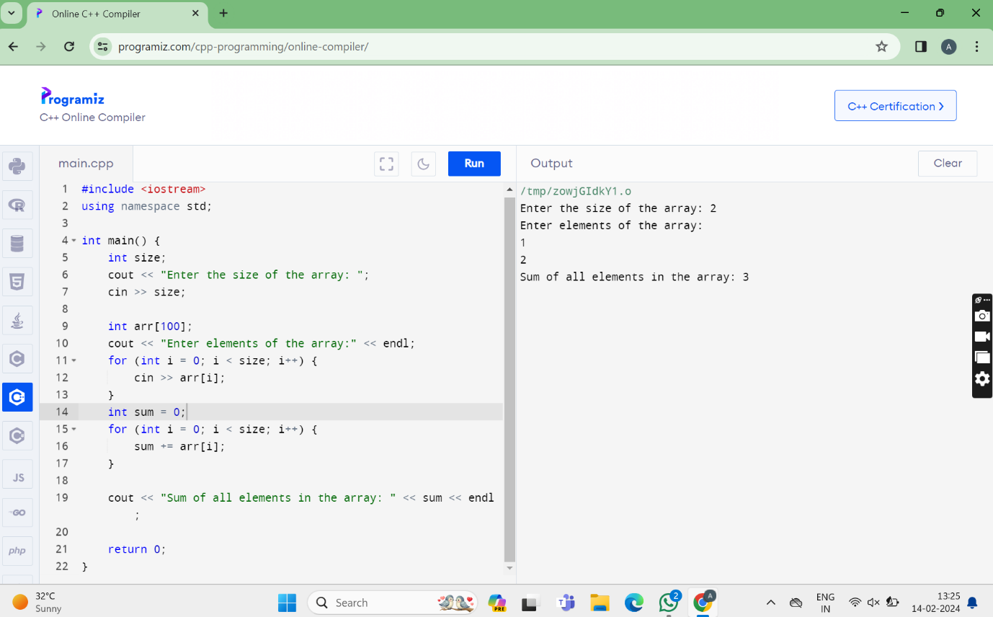

**2.PROGRAM TO PRINT SUMM OF ELEMENTS IN AN ARRAY**

#include <iostream>

using namespace std;

int main() {

int rows;

cout << "Enter the number of rows: ";

cin >> rows;

for (int i = 1; i <= rows; i++) {

for (int j = 1; j <= i; j++) {

cout << "*";

}

cout << endl;

}

return 0;

}

